NONIPILOT
AI Voice + Vision + Gesture Computer Agent
Complete Product Blueprint • Roadmap • Requirements • Architecture • Security • Implementation Plan

“Your Voice. Your Vision. Your Computer.”

Document | Value
Product | NoniPilot
Primary platform | Windows desktop
Core interaction | Natural voice commands
Multimodal interaction | Voice + screen vision + hand gestures
Execution model | Observe → Plan → Act → Verify → Recover
Target capability | Human-like desktop operation with controlled permissions
Document status | Complete planning baseline / implementation specification

1. Executive Product Vision
NoniPilot is planned as a native desktop AI agent that can understand natural-language voice commands, observe the computer screen, interact with Windows applications and files, control mouse and keyboard input, and interpret hand gestures through a webcam. The product is intended to move beyond fixed macros: it should reason about a user's goal, inspect the current computer state, select an appropriate action, execute it, verify the result, and recover when an action fails.
The design deliberately separates AI reasoning from privileged computer-control capabilities. This allows NoniPilot to be highly capable while retaining policy controls, confirmations, audit trails, emergency stop mechanisms, and permission boundaries.

2. Product Goals
- Provide a hands-free computer-control experience using natural voice.
- Allow NoniPilot to understand the current desktop rather than relying only on fixed screen coordinates.
- Perform multi-step tasks across files, folders, applications, browsers, terminals and supported enterprise software.
- Use webcam-based hand tracking for cursor movement, click, drag, zoom, scroll, selection and confirmation gestures.
- Verify completed actions and recover intelligently from common failures.
- Support both local/offline components and optional cloud AI components.
- Provide enterprise-grade security, permissions, audit logging and administrator policy.
- Start with Windows and maintain an extensible architecture for future platforms and plugins.

3. Non-Goals / Boundaries
- NoniPilot should not silently bypass security controls, authentication, endpoint protection or organizational policies.
- Destructive or high-impact operations must be governed by confirmation/policy rules.
- The agent should not assume that visual recognition is always correct; confidence and verification are required.
- The MVP should not attempt every possible application-specific workflow. It should establish a robust generic computer-control foundation first.

4. Core User Experience
Command | Expected NoniPilot behavior
“Open Chrome.” | Launch Chrome and verify the window is available.
“Open my Downloads folder.” | Open File Explorer at the configured Downloads location.
“Create a folder called Project Alpha on D drive.” | Navigate to D:, create the folder, verify it exists, report completion.
“Find today's PDFs and move them into Reports.” | Search, filter, create destination if required, move files, verify results.
“Open the latest backup report.” | Inspect relevant folder, determine newest matching report, open it.
“Create an Excel report from this data and save it to IT Reports.” | Plan application steps, create/edit workbook, save, verify output.
“Stop.” | Immediately halt active agent execution and release control inputs.
Point + pinch at a folder | Interpret hand position and pinch gesture as selection/click, subject to gesture mode.
Pinch and drag | Move a selected object/window when gesture drag mode is active.
Two-finger distance change | Map controlled finger-distance change to zoom in/out where supported.

5. Design Principles
- Observe before acting whenever screen state matters.
- Prefer semantic UI elements and accessibility APIs over hard-coded coordinates.
- Use coordinates only as a fallback when semantic control is unavailable.
- Never assume an action succeeded; verify the post-condition.
- Keep execution capabilities modular and permission-controlled.
- Maintain a complete action history for troubleshooting and audit.
- Allow the user to interrupt the agent at any point.
- Use confidence thresholds and confirmation for ambiguous or risky operations.
- Prefer extending existing capabilities over duplicating them in multiple subsystems.
- Keep AI provider interfaces abstract so models can be changed without rewriting the control engine.

6. High-Level Architecture
Recommended architecture: a Windows desktop shell hosts the user interface and secure control broker. An agent orchestration layer converts user intent into an executable task plan. Specialized engines provide voice, vision, gesture, filesystem, application, browser and computer-input capabilities.
Logical flow: Voice/Gesture → Intent → Planner → Policy Check → Observe → Action → Verification → Recovery/Next Step → Completion.
Layer | Major components | Purpose
Presentation | NoniPilot Desktop UI, command bar, live screen, task timeline, settings | User interaction and visibility.
Input | Speech-to-text, wake word, webcam, gesture recognizer | Convert human input into structured events.
Agent | Intent parser, planner, task state machine, memory, context manager | Understand goals and coordinate execution.
Perception | Screen capture, OCR/UI tree, vision model, application state | Understand current computer state.
Execution | Mouse, keyboard, window, filesystem, process, browser, PowerShell adapters | Perform controlled computer actions.
Policy | Permissions, confirmations, risk classifier, allow/deny rules | Control sensitive operations.
Verification | Post-condition checks, UI state comparison, file/process validation | Confirm that actions succeeded.
Persistence | SQLite local store; PostgreSQL/Redis for enterprise | Tasks, settings, audit and optional centralized state.
Extension | Plugin SDK, application adapters, enterprise connectors | Add capabilities without changing core architecture.

7. Recommended Technology Stack
Area | Recommended technology | Notes
Desktop shell | .NET / C# with WinUI 3 or WPF | Native Windows integration and mature desktop APIs.
Computer UI control | Windows UI Automation + Win32 APIs | Semantic UI interaction where possible.
Input simulation | Windows SendInput and controlled native APIs | Mouse/keyboard execution.
Screen capture | Windows Graphics Capture / compatible capture APIs | Low-latency desktop observation.
Vision | OpenCV + OCR + optional vision-capable AI model | Screen understanding and fallback visual grounding.
Hand tracking | MediaPipe Hands / equivalent local hand-tracking engine | Landmarks and gesture recognition.
Voice STT | Pluggable local or cloud speech engine | Offline/privacy mode plus optional higher-accuracy provider.
Voice TTS | Pluggable Windows/local/cloud TTS | Spoken responses.
Browser automation | Playwright or WebDriver-compatible adapter | Semantic browser interaction.
Local data | SQLite | Simple, reliable single-machine persistence.
Enterprise backend | PostgreSQL + Redis | Central policies, fleet telemetry, task history and management.
Packaging | MSIX or signed installer | Enterprise deployment and update management.
Testing | Unit + integration + UI automation + scenario tests | Regression protection.

8. Functional Requirements

8.1 Voice Engine
- Push-to-talk and configurable wake-word mode.
- Continuous command mode with explicit activation and cancellation.
- Noise handling, microphone selection and input-level feedback.
- Speech-to-text confidence and ambiguity handling.
- Text-to-speech responses with configurable voice, speed and volume.
- Support for command confirmation phrases such as Yes, No, Cancel and Stop.
- Optional offline speech mode for privacy-sensitive environments.

8.2 Agent / Planning Engine
- Convert natural language into structured intent.
- Generate multi-step task plans.
- Maintain task state and checkpoints.
- Select tools based on current computer state.
- Re-plan when an action fails or the UI changes.
- Support cancellation, pause/resume and retry.
- Maintain a bounded working context and persistent preferences where enabled.
- Return concise status updates during long-running tasks.

8.3 Screen Vision Engine
- Capture desktop or selected application windows.
- Identify UI controls using Windows UI Automation first.
- Use OCR for visible text when semantic metadata is unavailable.
- Use visual AI grounding as a fallback.
- Maintain confidence scores for detected targets.
- Detect state changes after actions.
- Support multi-monitor layouts and DPI scaling.

8.4 Mouse / Keyboard Engine
- Move, click, double-click, right-click, middle-click and scroll.
- Drag-and-drop and selection operations.
- Keyboard shortcuts, text input and key combinations.
- Window activation, minimize/maximize/restore and focus control.
- Input cancellation and emergency release.
- Rate limiting and action watchdog.

8.5 File & Folder Engine
- Create, copy, move, rename, compress, extract and inspect files.
- Create and navigate folders.
- Search by name, extension, size and timestamps.
- Handle local disks, mapped drives and approved network paths.
- Use file-operation verification and collision handling.
- Trash/recycle behavior for deletions where practical.
- Protect system-critical paths through policy.

8.6 Application Engine
- Launch, close and focus applications.
- Track application processes and windows.
- Use application adapters for complex workflows.
- Support generic UI Automation as the default.
- Allow administrators to restrict specific applications.

8.7 Browser Engine
- Open browser, tabs and URLs.
- Read and interact with accessible page elements.
- Fill forms and navigate pages.
- Download files to approved destinations.
- Detect navigation failures and login requirements.
- Never silently circumvent CAPTCHA, MFA or security controls.

8.8 Gesture Engine
- Webcam selection and privacy indicator.
- Hand landmark detection.
- Cursor pointing mode.
- Pinch-to-click.
- Pinch-and-drag.
- Scroll gesture.
- Zoom gesture based on controlled finger distance.
- Open-palm pause/release.
- Fist emergency stop.
- Thumbs-up confirmation and thumbs-down cancellation.
- Calibration, sensitivity and dwell-time settings.

8.9 Security & Policy
- Risk classification for every executable action.
- Permission profiles: Safe, Normal, Sensitive and Critical.
- User confirmation for risky actions.
- Administrator policy overrides.
- Protected path/application rules.
- Full audit log of commands, plans, actions and outcomes.
- Secure storage of credentials/tokens using Windows Credential Manager/DPAPI where applicable.
- Signed binaries and update packages.
- Kill switch and emergency input stop.

9. Permission & Risk Model
Level | Examples | Default behavior
L0 Safe | Open apps, read directories, search, scroll, inspect | Execute automatically.
L1 Normal | Create folders, rename, move non-sensitive files, download | Execute with policy checks; configurable confirmation.
L2 Sensitive | Delete files, install software, run elevated tools, change settings | Require explicit user confirmation unless an administrator policy explicitly permits it.
L3 Critical | Format disk, destructive bulk deletion, disable security controls, security/account changes | Always require explicit confirmation and policy authorization; never silently execute.

10. Safety & Recovery Requirements
- Global emergency stop must interrupt active mouse/keyboard automation.
- Long-running tasks must have timeouts and heartbeats.
- Every high-impact action should have a reversible alternative when available.
- File deletion should prefer Recycle Bin where appropriate.
- Bulk operations should show scope before execution when risk is elevated.
- The agent must detect loss of screen/application context and re-observe instead of blindly continuing.
- If confidence is below threshold, NoniPilot should ask a clarification question.
- If a task encounters authentication, MFA, CAPTCHA or security prompts, NoniPilot should pause and request user intervention rather than bypassing them.
- The user must be able to see what NoniPilot is doing during active automation.

11. Desktop UI / UX Specification
- Modern futuristic enterprise visual design without sacrificing readability.
- Primary command input with microphone state and push-to-talk control.
- Live computer preview with optional red/green action indicators.
- Current task plan displayed as a timeline.
- Action-by-action status: Pending, Running, Verified, Failed, Waiting for User.
- Large emergency STOP button.
- Gesture status panel showing webcam/hand tracking state.
- Permission prompt modal showing exactly what action is requested and why.
- Task history with searchable command, execution steps and result.
- Settings for voice, camera, AI provider, security, directories, plugins and privacy.
- Accessibility: keyboard-only operation, scalable UI, high contrast and screen-reader-friendly controls.

12. Suggested Main Screens
Screen | Key content
Home / Command Center | Voice command, live screen, current task, quick actions, system state.
Live Agent | Current screenshot, detected UI target, plan, active action, verification result.
Task History | Past commands, duration, actions, result, errors, replay metadata.
Files & Permissions | Approved paths, protected paths, file-operation policies.
Gesture Center | Camera preview, landmarks, gesture mapping, calibration.
Applications | Installed/approved application adapters and permissions.
Security Center | Risk policy, confirmations, audit log, emergency controls.
AI Settings | Model/provider selection, local/cloud mode, token/configuration status.
Plugins | Installed adapters, permissions and enable/disable controls.
Enterprise Console (future) | Agents, devices, users, policies, health, audit and deployments.

13. Core Data Model
Entity | Important fields
UserProfile | id, display_name, preferences, voice settings, gesture settings
Task | id, command, intent, status, started_at, completed_at, risk_level, result
TaskStep | id, task_id, sequence, tool, action, parameters, status, confidence
Observation | id, task_id, timestamp, screen/window metadata, detected elements
PermissionPolicy | id, scope, risk_level, action, path/app restrictions, approval mode
AuditEvent | id, task_id, actor, action, target, outcome, timestamp, metadata
Plugin | id, name, version, capabilities, permissions, enabled
DeviceProfile | id, machine_name, OS, agent_version, capabilities, health
CredentialReference | id, provider, target, secure reference; no plaintext secret storage

14. Internal Service Interfaces
- ICommandInputService — receives voice/text/gesture events.
- IIntentService — converts natural language into structured intent.
- IPlannerService — creates and updates task plans.
- IPolicyService — evaluates action permissions and confirmation requirements.
- IObservationService — captures and interprets current desktop state.
- IComputerControlService — executes mouse, keyboard and window actions.
- IFileSystemService — performs controlled file operations.
- IApplicationService — launches and manages applications.
- IBrowserService — performs browser automation.
- IGestureService — tracks hands and maps gestures to semantic commands.
- IVerificationService — checks post-conditions.
- IAuditService — persists task/action audit records.
- IPluginService — loads capability adapters under policy control.

15. Complete Implementation Roadmap

Phase 0 — Product Foundation (1–2 weeks)
- Finalize UX, threat model, permission matrix and architecture.
- Create repository, coding standards, CI pipeline and issue structure.
- Define interfaces and domain models before implementing adapters.

Phase 1 — Windows Desktop MVP (3–5 weeks)
- Native desktop shell.
- Voice input/output.
- Basic command interpreter.
- Mouse and keyboard control.
- Application launch/focus.
- Basic filesystem operations.
- Task history and emergency stop.

Phase 2 — Observe/Act/Verify Agent (4–6 weeks)
- Screen capture.
- Windows UI Automation tree.
- OCR.
- Visual grounding fallback.
- Task planner/state machine.
- Post-condition verification.
- Retry/recovery engine.

Phase 3 — Browser & Office Automation (3–5 weeks)
- Browser adapter.
- Office/application adapters where useful.
- Downloads, forms, document creation and verification.
- Long-running task handling.

Phase 4 — Gesture Control (3–4 weeks)
- Webcam integration.
- Hand landmark detection.
- Calibration.
- Pointer, pinch, drag, scroll and zoom.
- Gesture confirmation and emergency stop.

Phase 5 — Advanced Agent (4–8 weeks)
- Persistent preferences/memory.
- Complex task decomposition.
- Parallel observation where safe.
- Better recovery strategies.
- Plugin SDK.
- Offline/local AI modes.

Phase 6 — Enterprise Edition (6–10+ weeks)
- Central management server.
- PostgreSQL + Redis.
- Agent registration and fleet health.
- RBAC and centralized policy.
- Audit dashboards.
- Software update management.
- Organization-wide deployment controls.

16. MVP Acceptance Criteria
- User can activate NoniPilot and issue a natural voice command.
- NoniPilot can launch a known application.
- NoniPilot can navigate folders and create/rename/move files.
- NoniPilot can control mouse and keyboard reliably on supported Windows environments.
- NoniPilot can inspect screen state and identify common controls.
- NoniPilot verifies at least one post-condition for every supported multi-step workflow.
- User can stop automation immediately.
- Risky operations trigger the appropriate confirmation.
- Task history records the command, actions and final result.
- Gesture MVP can move the pointer and perform at least click, drag, scroll and zoom gestures with calibration.
- No plaintext credentials are stored by the application.

17. Testing Strategy
Test category | Examples
Unit | Planner, risk classifier, gesture state machine, file path validation.
Integration | Voice → intent → planner → file operation → verification.
UI automation | Open Explorer, select folder, create item, verify.
Vision | Different DPI, themes, resolutions, multi-monitor layouts.
Gesture | Lighting, backgrounds, skin-tone diversity, hand angles, left/right hand.
Failure recovery | Window closed, application hangs, target missing, permissions denied.
Security | Protected paths, privilege escalation attempts, malicious prompt content, policy bypass.
Performance | CPU/GPU usage, screen capture latency, gesture FPS, memory stability.
Soak | Long-running tasks and repeated commands over many hours.

18. Security Architecture
- Run the core desktop UI with normal user privileges by default.
- Use a separate, tightly controlled privileged broker only where elevated operations are genuinely required.
- Broker commands must be allowlisted and parameter-validated.
- Use Windows Credential Manager/DPAPI or equivalent secure storage for secrets.
- Sign installers, binaries and update packages.
- Verify update signatures before installation.
- Maintain tamper-aware audit logs.
- Protect the policy configuration from ordinary application-level modification.
- Provide organization-level controls for disabling webcam, cloud AI, external network access or specific plugins.
- Treat AI-generated instructions as untrusted input and enforce policy outside the model.

19. Privacy Architecture
- Provide a clearly visible microphone state.
- Provide a clearly visible camera/gesture state.
- Default to minimum required data retention.
- Allow users/administrators to disable screen-image retention.
- Separate transient screen observations from persistent audit data.
- Offer local-only processing for environments that cannot send screen/audio data to external AI services.
- Provide configurable retention and deletion policies for task history.

20. Enterprise Edition Roadmap
- Central administration portal.
- Agent registration and certificate/device identity.
- Role-based access control.
- Centralized action policies.
- Device groups and application policies.
- Agent health monitoring.
- Central audit and compliance reporting.
- Controlled software rollout and rollback.
- Optional private AI gateway for organizations that require internal model hosting.
- Multi-tenant architecture only if a hosted SaaS version is eventually required.

21. Recommended Repository Structure
NoniPilot/
├── src/
│ ├── NoniPilot.Desktop/
│ ├── NoniPilot.Agent/
│ ├── NoniPilot.Domain/
│ ├── NoniPilot.Policy/
│ ├── NoniPilot.Vision/
│ ├── NoniPilot.Voice/
│ ├── NoniPilot.Gesture/
│ ├── NoniPilot.ComputerControl/
│ ├── NoniPilot.FileSystem/
│ ├── NoniPilot.Browser/
│ ├── NoniPilot.Applications/
│ ├── NoniPilot.Verification/
│ ├── NoniPilot.Audit/
│ └── NoniPilot.PluginSdk/
├── plugins/
│ ├── Browser/
│ ├── Office/
│ └── Enterprise/
├── tests/
│ ├── Unit/
│ ├── Integration/
│ ├── UI/
│ ├── Vision/
│ └── Gesture/
├── docs/
│ ├── architecture/
│ ├── security/
│ ├── api/
│ └── operations/
├── installer/
└── README.md

22. Recommended Development Team
Role | Initial responsibility
Product/Technical Lead | Architecture, scope, roadmap, technical decisions.
Windows/.NET Engineer | Desktop shell, UI Automation, Win32, input control.
AI/Agent Engineer | Intent, planning, tool selection, verification and recovery.
Computer Vision Engineer | Screen perception, OCR, visual grounding.
Voice Engineer | STT/TTS integration and audio UX.
Computer Vision/Gesture Engineer | Hand tracking and gesture recognition.
Security Engineer | Threat model, privilege boundaries, policy and audit.
QA/Automation Engineer | Scenario tests, regression suite, reliability testing.

23. Major Risks and Mitigations
Risk | Mitigation
Wrong visual target | Semantic UI Automation first; confidence thresholds; verification; confirmation.
AI misunderstands command | Clarification, structured intent, preview for risky actions.
Destructive action | Risk engine, confirmation, protected paths, privileged broker.
Gesture false positive | Calibration, dwell time, confidence, explicit gesture mode.
Application UI changes | Semantic selectors, visual fallback, adapters, re-observation.
AI/provider outage | Provider abstraction and optional local engines.
High CPU/GPU usage | Adaptive capture rate, event-driven observation, configurable quality.
Security compromise | Signed binaries, least privilege, isolated broker, allowlists, audit.
Long task gets stuck | Timeouts, watchdog, state checkpoints, cancellation and recovery.

24. Initial Product Backlog
- Create NoniPilot solution and CI pipeline.
- Build command-center desktop UI.
- Implement microphone selection and push-to-talk.
- Integrate first STT provider behind an interface.
- Implement TTS provider interface.
- Implement task/step state machine.
- Implement mouse control service.
- Implement keyboard control service.
- Implement window management service.
- Implement filesystem service.
- Implement application launcher.
- Implement screen capture.
- Implement Windows UI Automation observer.
- Implement OCR observer.
- Implement visual grounding adapter.
- Implement policy/risk service.
- Implement confirmation dialog.
- Implement emergency stop.
- Implement audit service.
- Implement task history.
- Implement browser adapter.
- Implement gesture tracking.
- Implement gesture calibration.
- Implement gesture-to-action mapper.
- Implement verification engine.
- Implement retry/recovery engine.
- Implement plugin SDK.
- Implement enterprise management backend.

25. Example End-to-End Task Specifications
Scenario | User input | Agent behavior
File organization | “Find all PDFs in Downloads larger than 10 MB and move them into D:\Reports\Large PDFs.” | Search → filter → policy check → create destination if needed → move → verify counts → report.
Document creation | “Create a Word report summarizing this text and save it to my IT Reports folder.” | Read input → create document → format → save → verify file → optionally open.
Browser workflow | “Open the company portal and show me the pending requests.” | Open browser → navigate → authenticate if required → inspect page → summarize; pause for user authentication/MFA.
Visual interaction | “Move that window to the right monitor.” | Detect referenced window → determine target monitor → drag/move → verify window position.
Gesture | Point at an icon, pinch, drag and release. | Track hand → map fingertip to screen → pinch state → drag target → release → verify.

26. Release Strategy
- Alpha: developer machines only; extensive logging and manual confirmations.
- Private Beta: selected trusted users; gesture and vision calibration feedback.
- Release Candidate: signed installer, crash reporting, performance profiling, security review.
- v1.0: stable Windows desktop agent with voice, generic computer control, files, applications, verification and gesture MVP.
- v1.x: browser, Office, plugins, local AI improvements and enterprise controls.
- v2.x: centralized fleet management, advanced multimodal planning and enterprise policy.

27. Definition of Done for a NoniPilot Feature
- Requirement is documented.
- Threat/risk impact is assessed.
- Implementation uses the correct service interface.
- Unit tests exist.
- Integration/scenario test exists where applicable.
- Failure and cancellation behavior is defined.
- Audit behavior is defined.
- User-facing status/error message is defined.
- Documentation is updated.
- No security policy is bypassed by model-generated actions.

28. Recommended First Build Order
- Create the native Windows desktop shell and command-center UI.
- Create the domain models and task state machine.
- Build mouse, keyboard, window and filesystem services.
- Add emergency stop and policy engine before enabling autonomous execution.
- Add voice input/output.
- Add screen capture + Windows UI Automation.
- Build the Observe → Plan → Act → Verify loop.
- Add browser/application adapters.
- Add gesture engine and calibration.
- Add plugin SDK and enterprise backend after the single-machine agent is reliable.

29. Final Product Definition
NoniPilot should be treated as an AI operating layer for the user's Windows desktop rather than as a voice macro utility. Its defining capability is multimodal, state-aware computer operation: it listens, understands, observes, plans, acts, verifies and recovers. Voice is the primary command interface; screen vision supplies context; hand gestures provide a natural secondary control surface; Windows-native automation provides reliable execution; and the policy engine keeps high-impact actions under explicit control.
The recommended implementation strategy is to establish a highly reliable single-computer Windows agent first, then expand into application plugins, gesture control, advanced multimodal reasoning and finally centralized enterprise management. This sequencing minimizes architectural rework and ensures that every later AI capability is built on a dependable execution and security foundation.

30. Next Implementation Deliverables
- NoniPilot Software Requirements Specification (SRS).
- NoniPilot System Architecture and component diagrams.
- NoniPilot database schema and API specification.
- NoniPilot Windows desktop project skeleton.
- NoniPilot security threat model and permission matrix.
- NoniPilot UI wireframes and design system.
- NoniPilot Phase-1 source-code implementation.
- NoniPilot automated test suite and deployment package.

NoniPilot — Complete Product Blueprint
Prepared as the baseline specification for phased implementation.

31. NoniPilot Demo Visual Concepts
The following concept images illustrate the intended product experience. They are design/demo visuals, not screenshots of a completed implementation. They can be used as references for UI/UX and engineering discussions.
NoniPilot Command Center
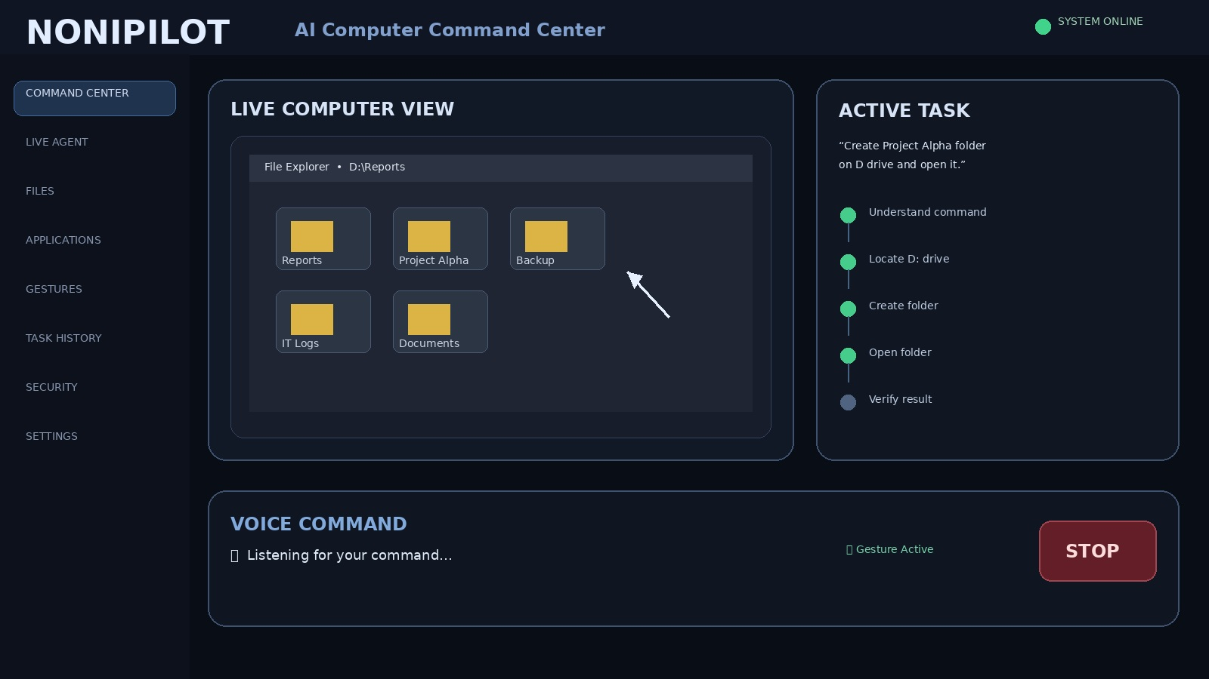
Futuristic desktop command center with live computer view, active task plan, voice state and emergency stop.

Gesture Control
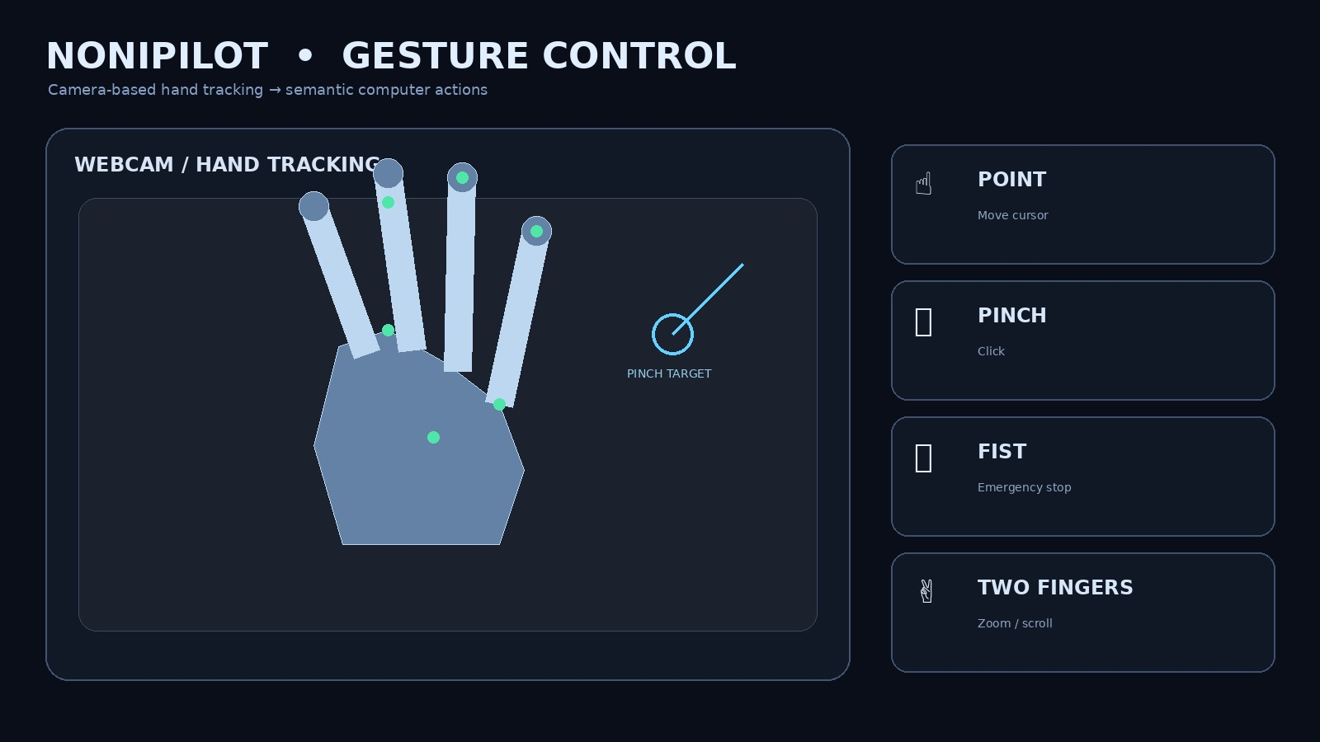
Webcam hand tracking concept showing point, pinch, emergency-stop and two-finger gesture mappings.

Multimodal Agent Architecture
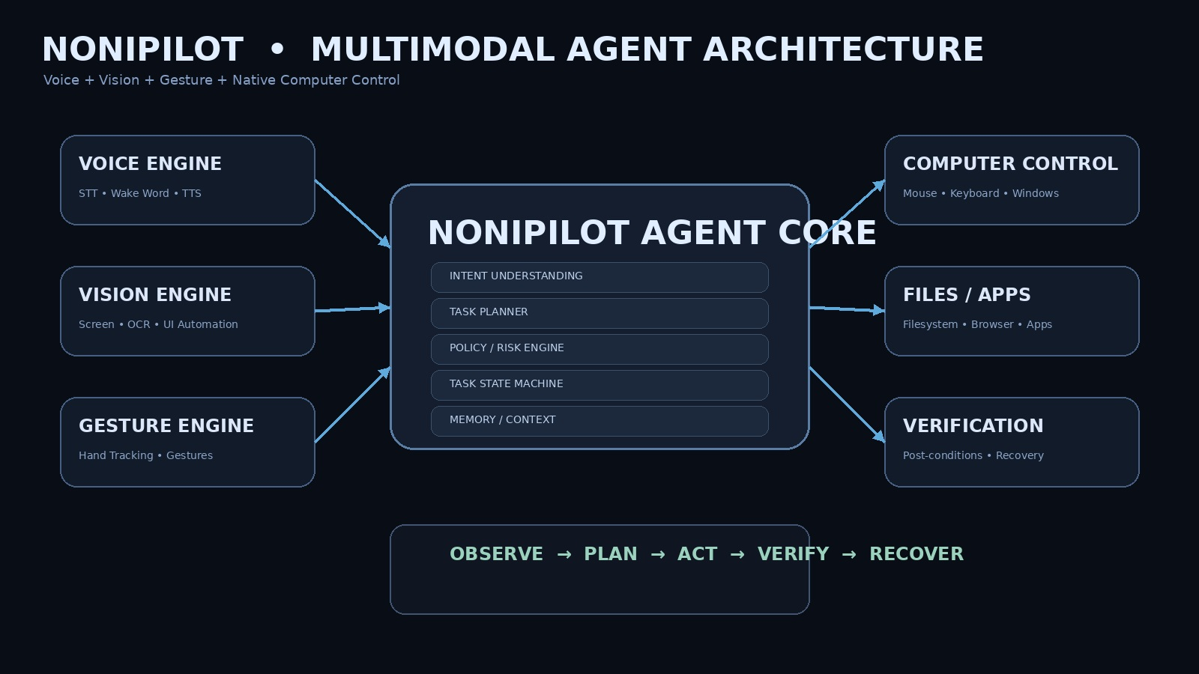
High-level architecture showing Voice, Vision and Gesture feeding the NoniPilot Agent Core and controlled execution layers.

Security & Human Control
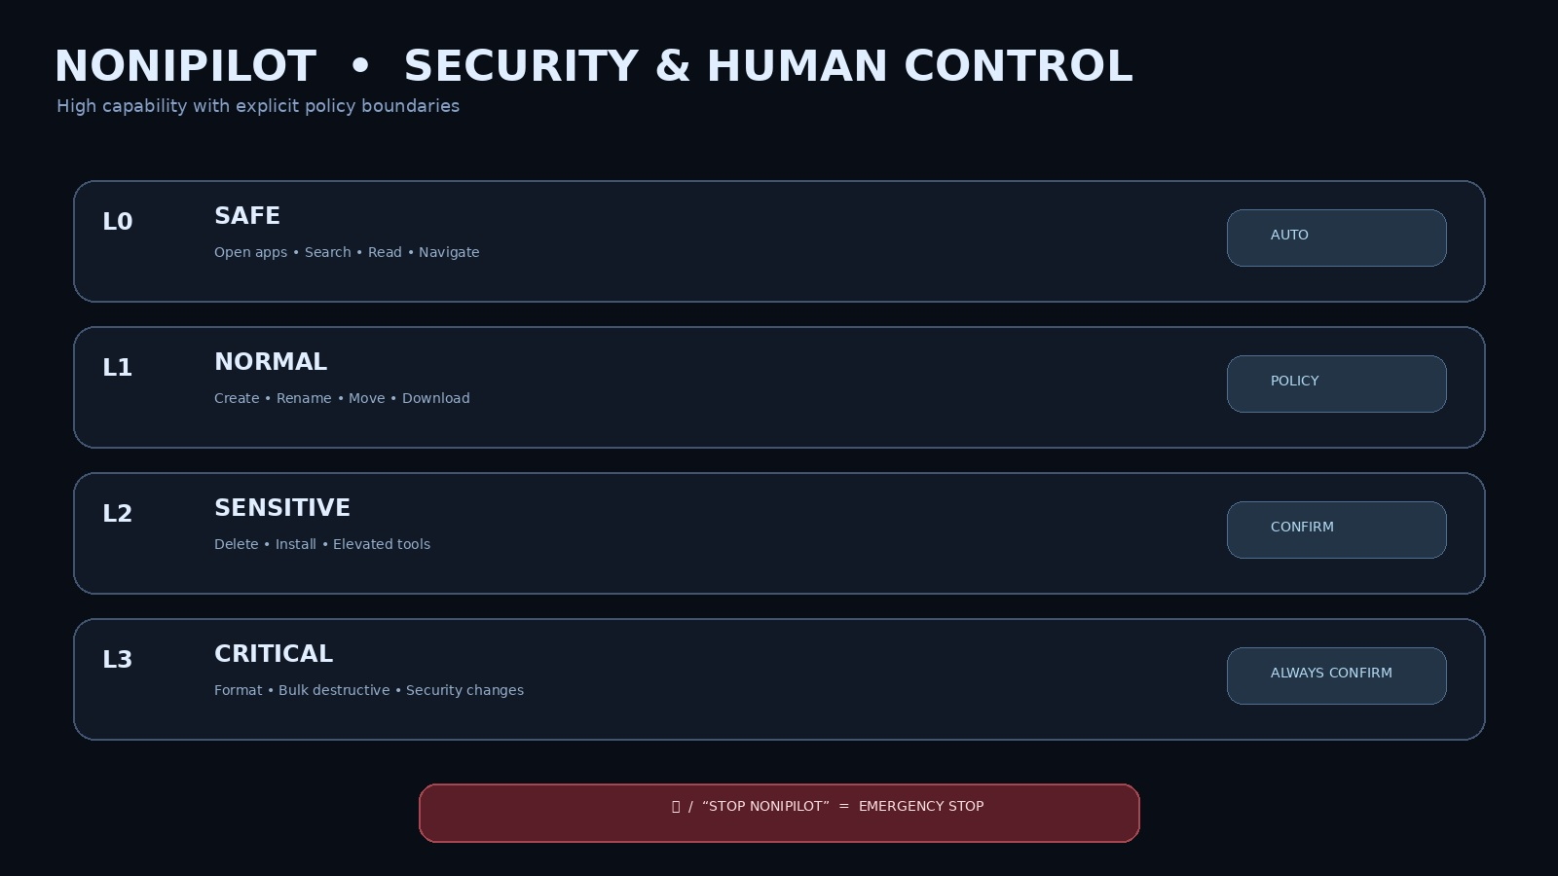
Risk-tier concept demonstrating automatic, policy-controlled and confirmation-required actions.

